

(INTEGRATIVE PROGRAMMING AND TECHNOLOGIES)

EXERCISE
9

(Network Programming)

Name of Student | Name of Professor
Justine Guillermo
Data Performed | Date Submitted

SERVER

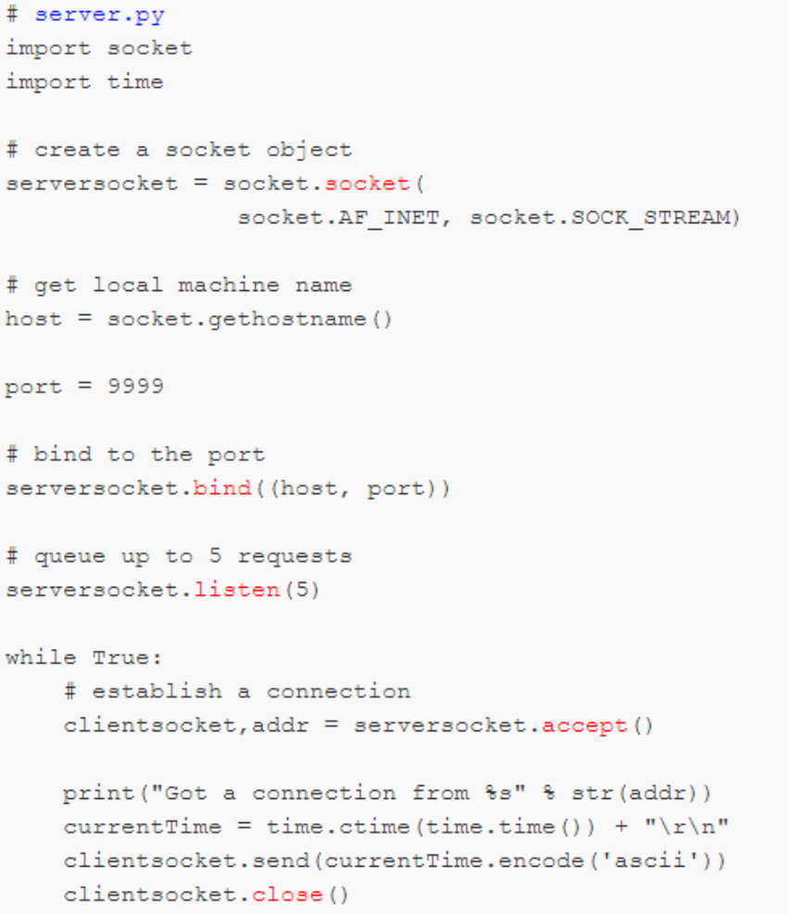

CLIENT
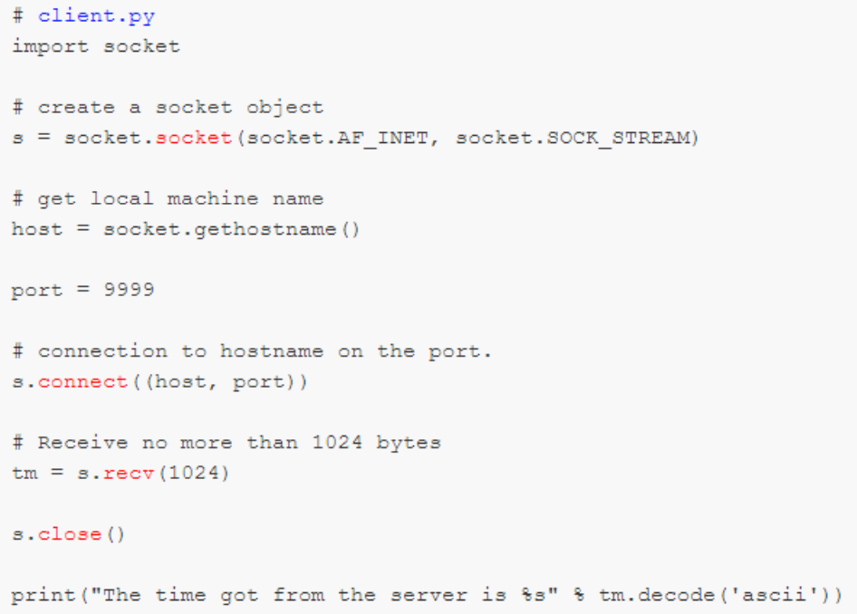

OUTPUT
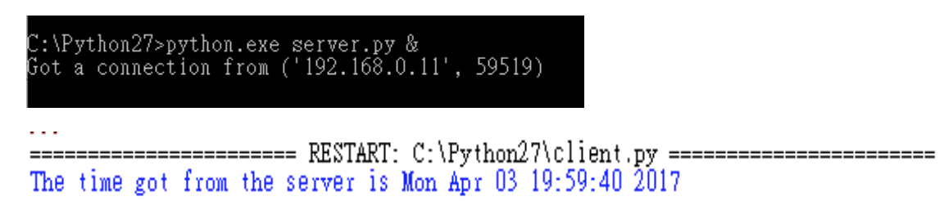

SERVER
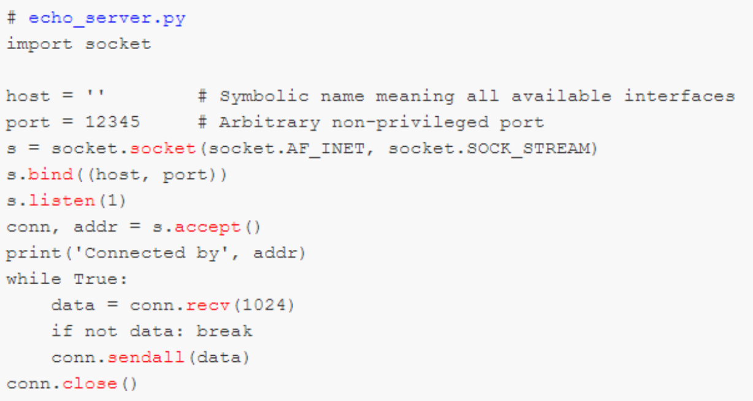

CLIENT
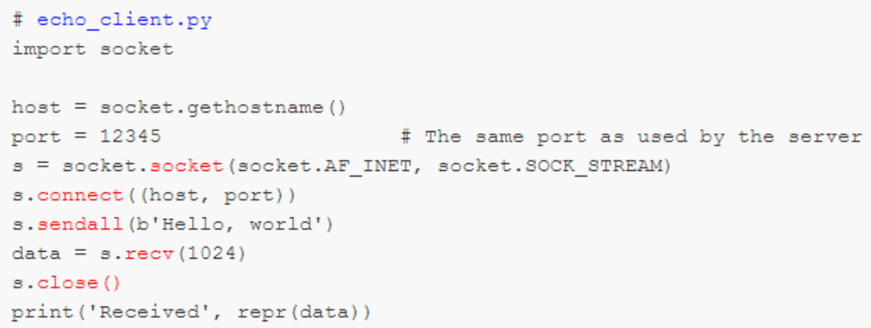

OUTPUT
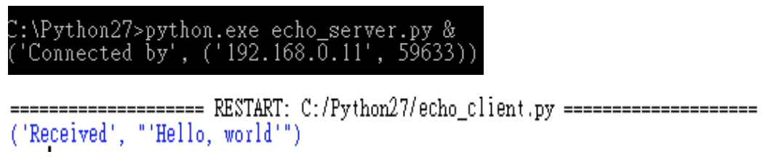`

CHAT APPLICATION
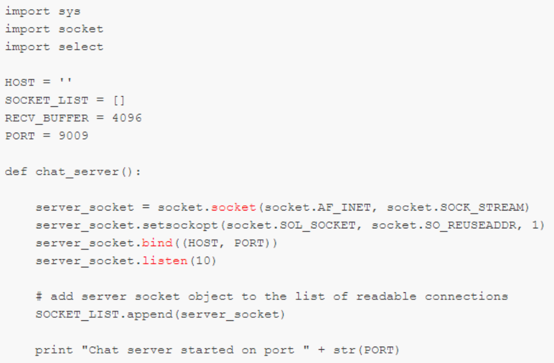
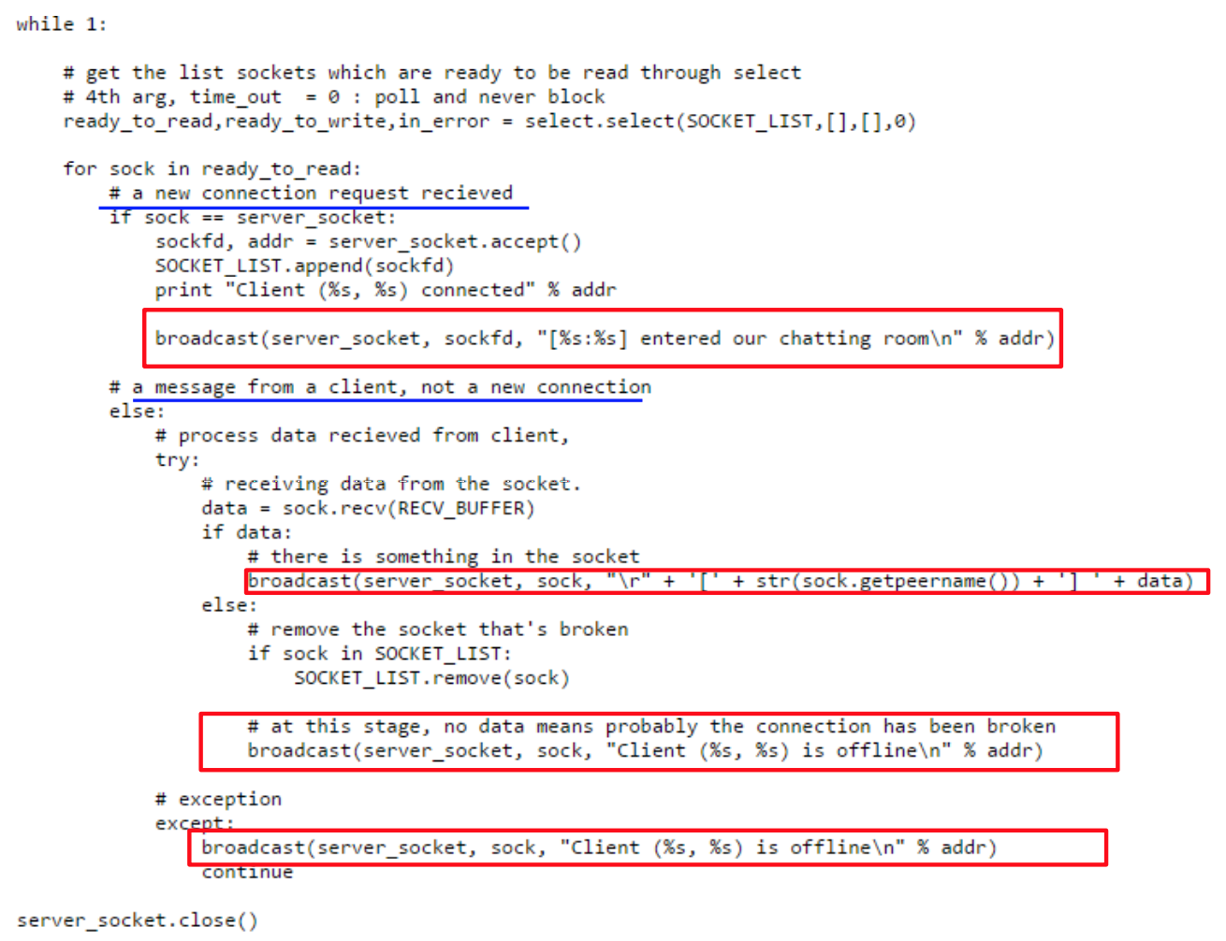
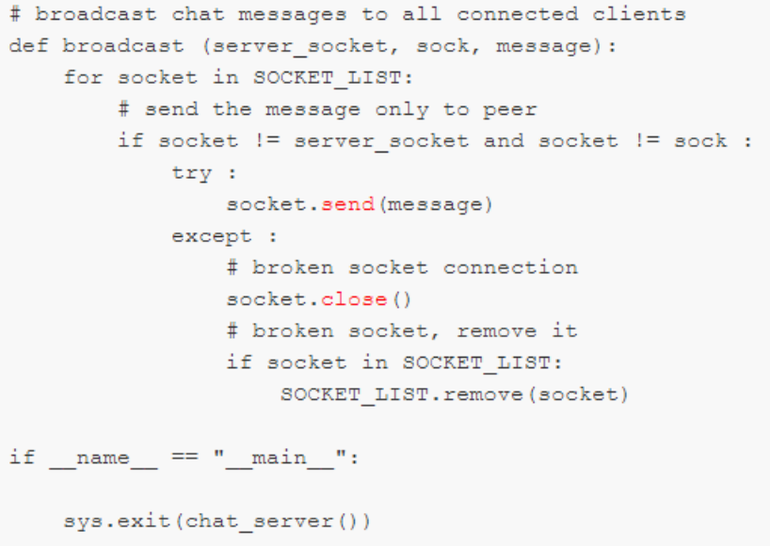

CLIENT CODE
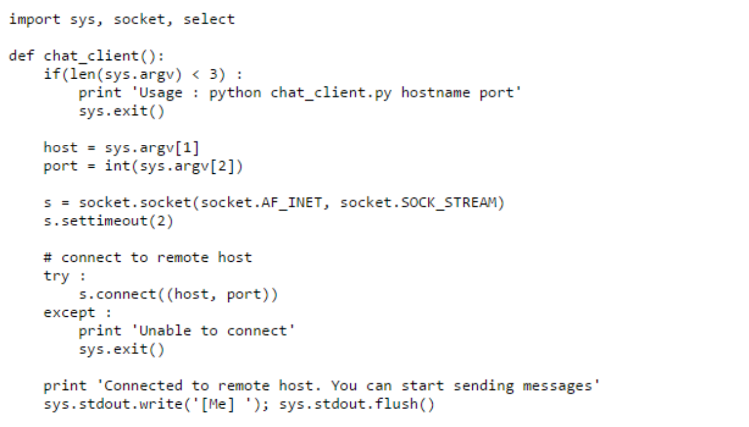

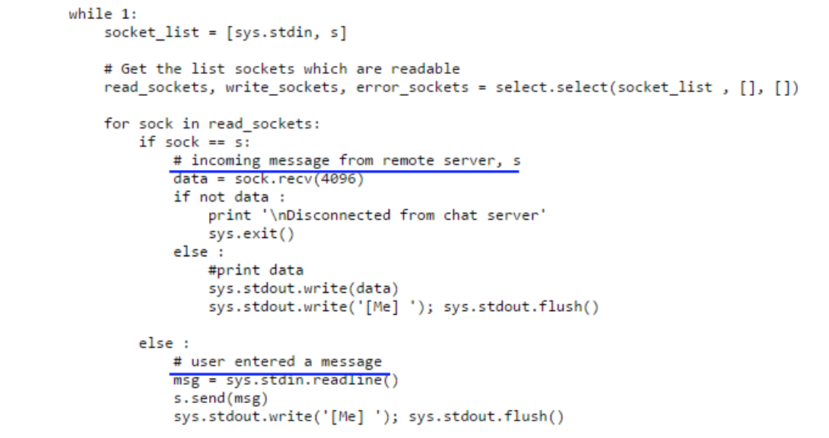

SERVER TERMINAL
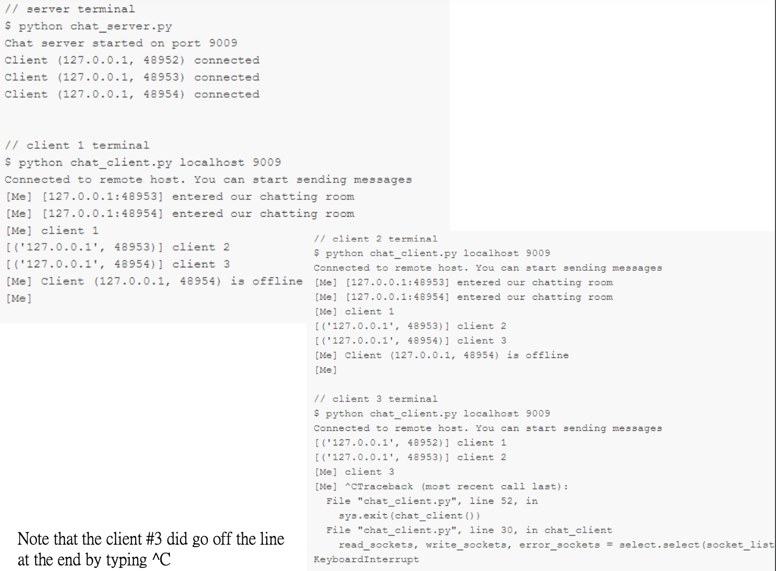

Connection

Server:
import socket
print("Ready for connection")
s = socket.socket()
host = socket.gethostname()
port = 1248
s.bind((host, port))
s.listen(5)
while True:
c, addr = s.accept()
print(f'Got Connection from {addr}')
v = b'You are connected!'
c.send(v)
c.close()

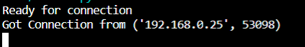

Client:
import socket
try:
s = socket.socket()
host = socket.gethostname()
port = 1248
s.connect((host,port))
print(s.recv(1024))
s.close()
except ConnectionRefusedError:
print("Server not available!")

